IN THE FOOTSTEPS OF GIANTS – ONLINE!
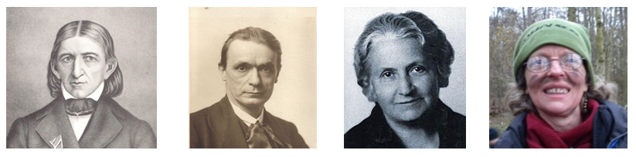
Six hour-long sessions on the under-pinning principles of play-based kindergarten practice for children aged three to seven. Each will be an hour long, broadcast live on Zoom at 7pm and available to registrants for a week.
The first four will consist of 20 minute presentations plus discussion and Q/A:
7pm, Thursday, 10th September 2020
Marjorie Ouvry on Friedrich Froebel
Are you a Froebelian? How relevant are the
ideas of Friederich Froebel to our work today?
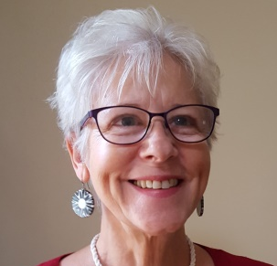
7 pm, Thursday 17th September 2020
Janni Nichol on Rudolf Steiner
Early Childhood: Preparation for Life
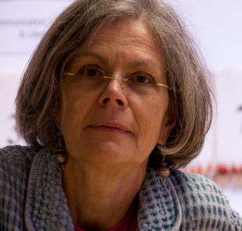
7 pm, Thursday 24th September 2020
Barbara Isaacs on Maria Montessori
Montessori pedagogy and its relevance to 21st
century children and their families
7 pm Thursday 1stOctober 2020
Sarah Latto
from Cathy Bache’s Secret Garden
Outdoor kindergarten: Presence; Nature; Play
Week beginning Monday October 5th: a selection of workshops related to the above presentations. Further details to be announced

7 pm, Thursday 15th October: Panel discussion and Q/A.

